St. Patrick’s C of E Primary Academy
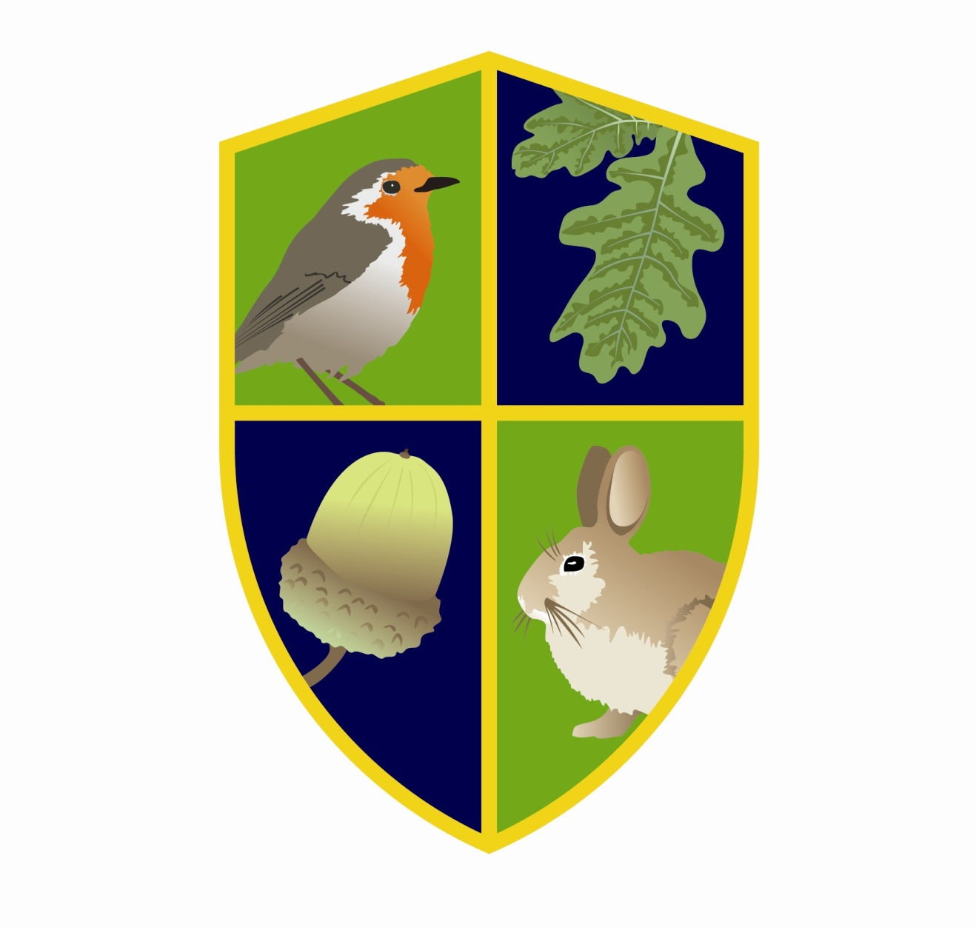
Foundation Stage
Booklet

Contents

 | 3 |  | Welcome to St. Patrick’s
 | 4 |  | Our Foundation Stage Team
 | 5 |  | How we support learning in our Foundation Stage
 | 6 |  | The Foundation Stage Curriculum
 | 8 |  | Assessment
 |  |  | How can you support us and your child?
 | 9 |  | How can you support your child at home?
 | 11 |  | General Information
 | 13 |  | Play-dough Recipe

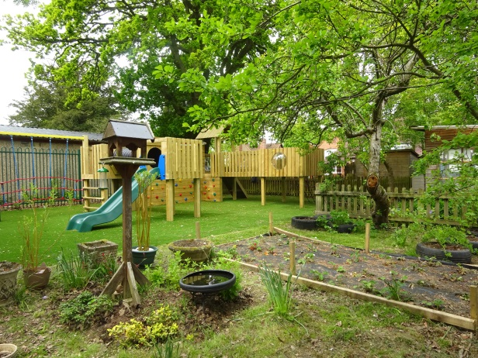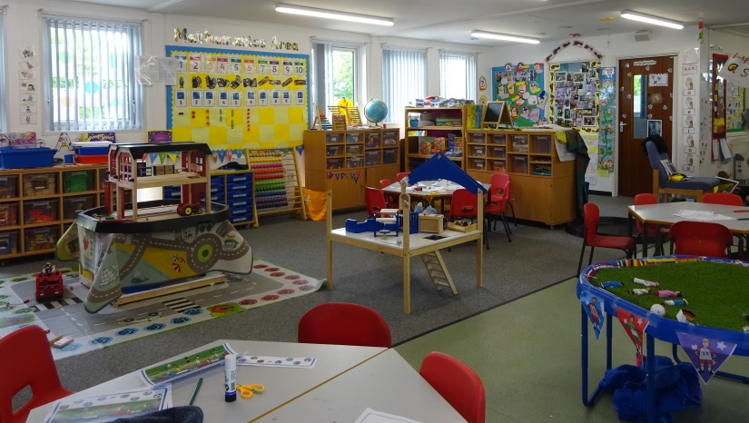
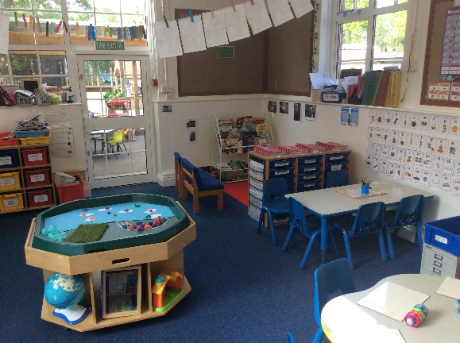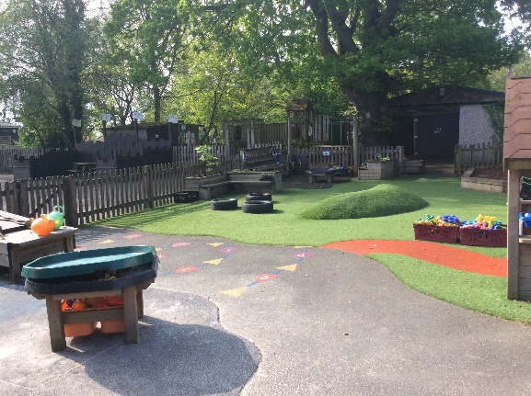
Welcome to St. Patrick’s CE Primary Academy
We would like to extend a warm welcome to you and your family.
We appreciate that starting school is a big step for both you and your child and here at St. Patrick’s we aim to make this a happy and positive event. At St. Patrick’s we pride ourselves on nurturing independent and happy children who take risks and enjoy challenges. Our indoor and outdoor classrooms help each individual child develop their own unique personalities and find their own paths of interest from which to form their own learning journeys.
We hope this guide will provide you with useful information about the Early Years Foundation Stage Curriculum and our setting. It will provide a brief outline of the learning your child will be involved in during their time in our Nursery and Reception classes. It also includes some ideas of ways in which you may be able to help your child at home to support their learning.
When children start Nursery and Reception they bring with them a wide range of varied experiences. They have already learnt a great deal, particularly from their families, and the skills that they have already developed provide a firm foundation for their future learning. The range of activities we provide at St. Patrick’s are carefully planned to build on what they already know. We believe that children flourish best when home and school work together to provide the best possible learning experiences.
We look forward to working in partnership with you at the beginning of your child’s learning journey with us.

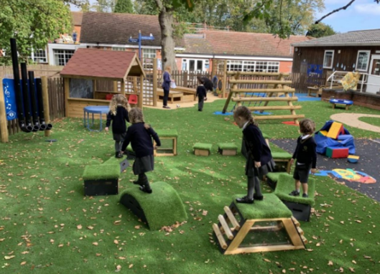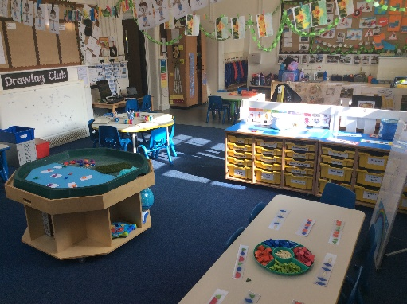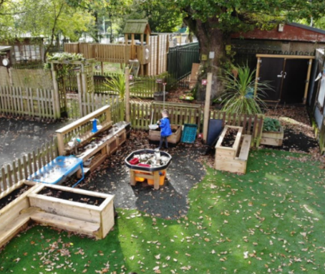
The Magnificent Seven at St. Patrick’s
Our seven magnificent values which our St. Patrick’s family adhere to are:
Honesty Respect Kindness Trust
Hope and dreams Enjoyment Thankfulness
Our Foundation Stage Team

 | 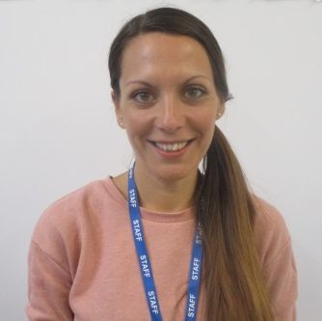 | 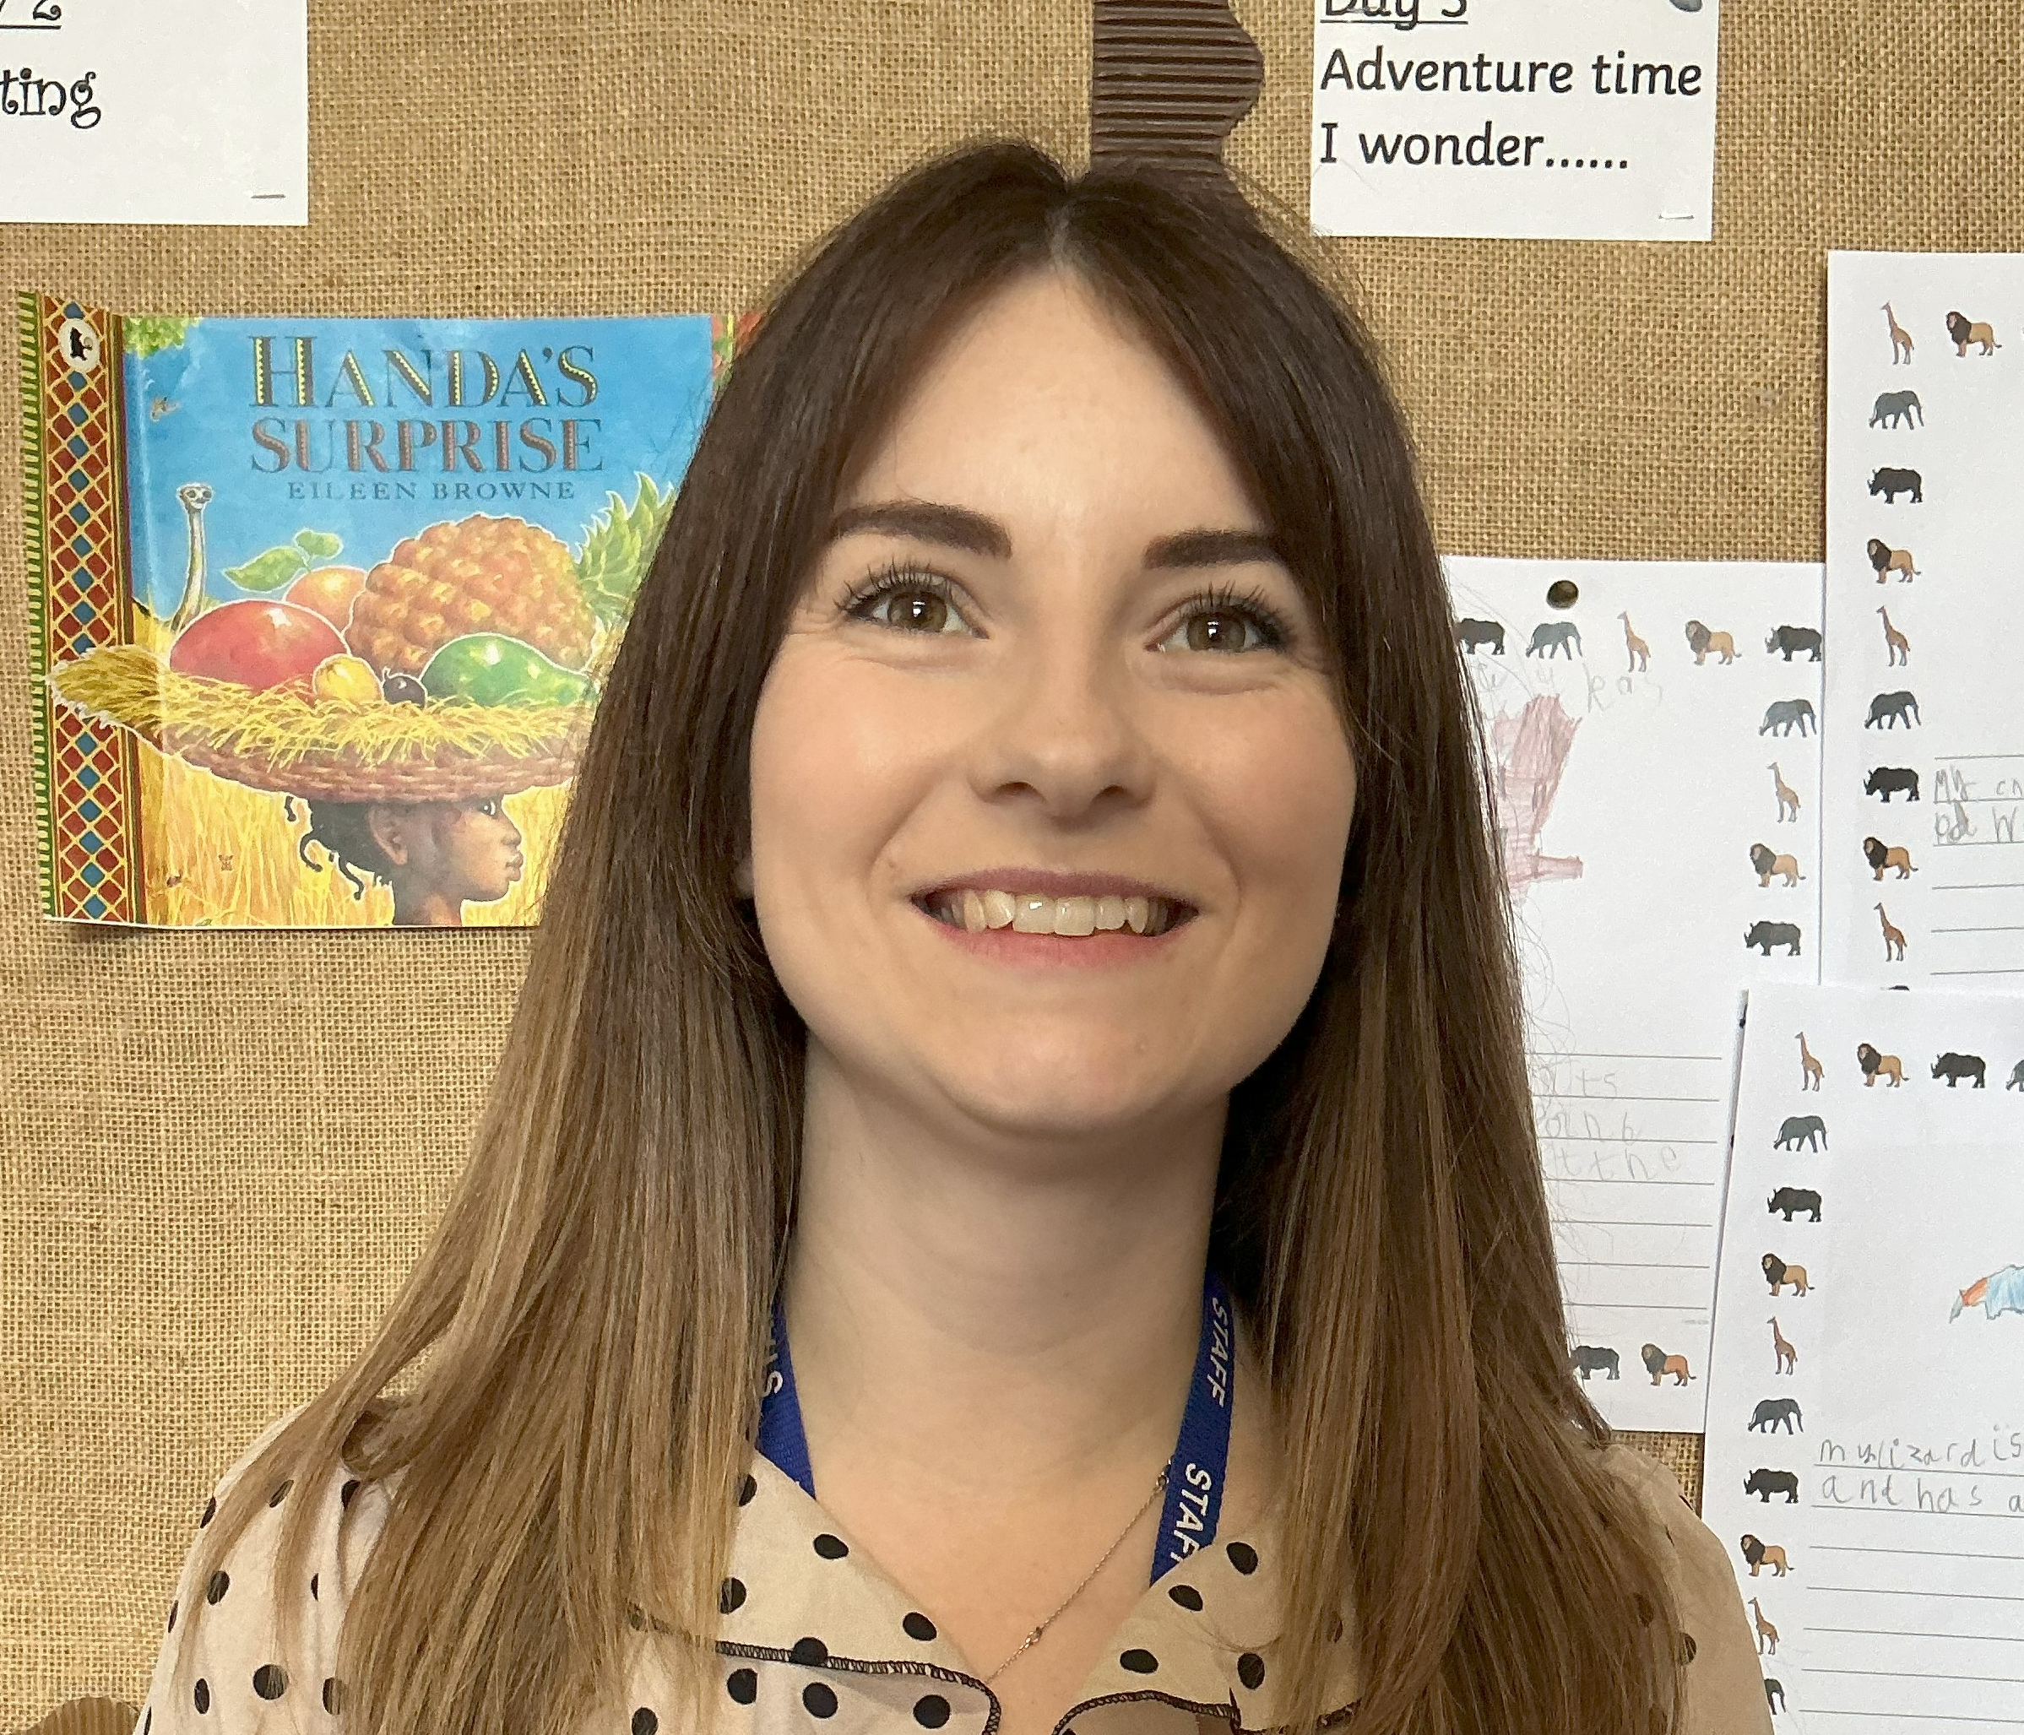
Mrs Blick  Nursery Class Teacher  (EYFS Lead) | Mrs Jones  Reception Class Teacher | Mrs Brooks  Reception Class Teacher

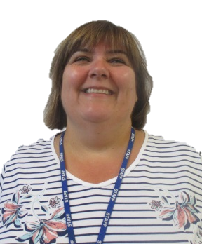 | 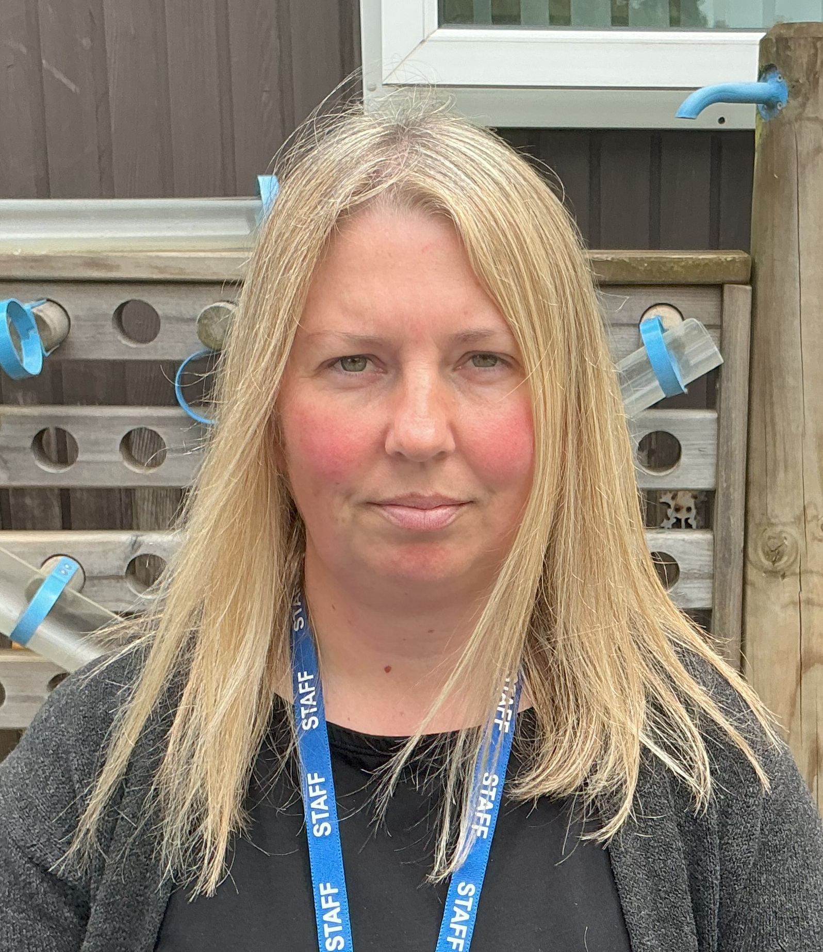 |  | 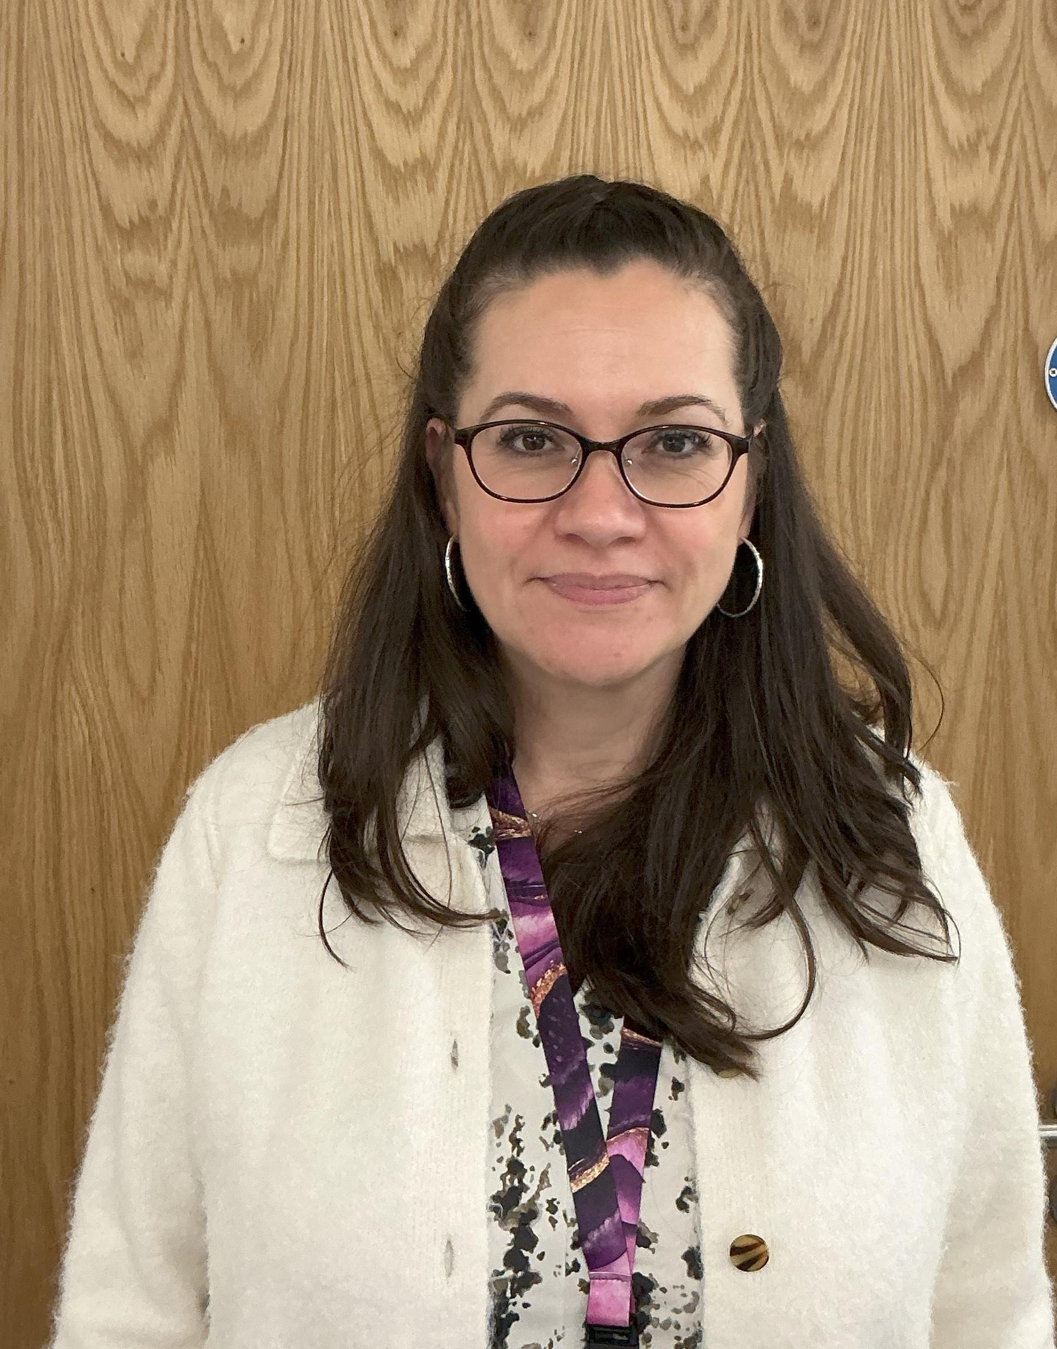
Miss Benson  Teaching & Learning Assistant | Miss Hinson  Teaching & Learning Assistant |  | Mrs Wright  Teaching & Learning Assistant
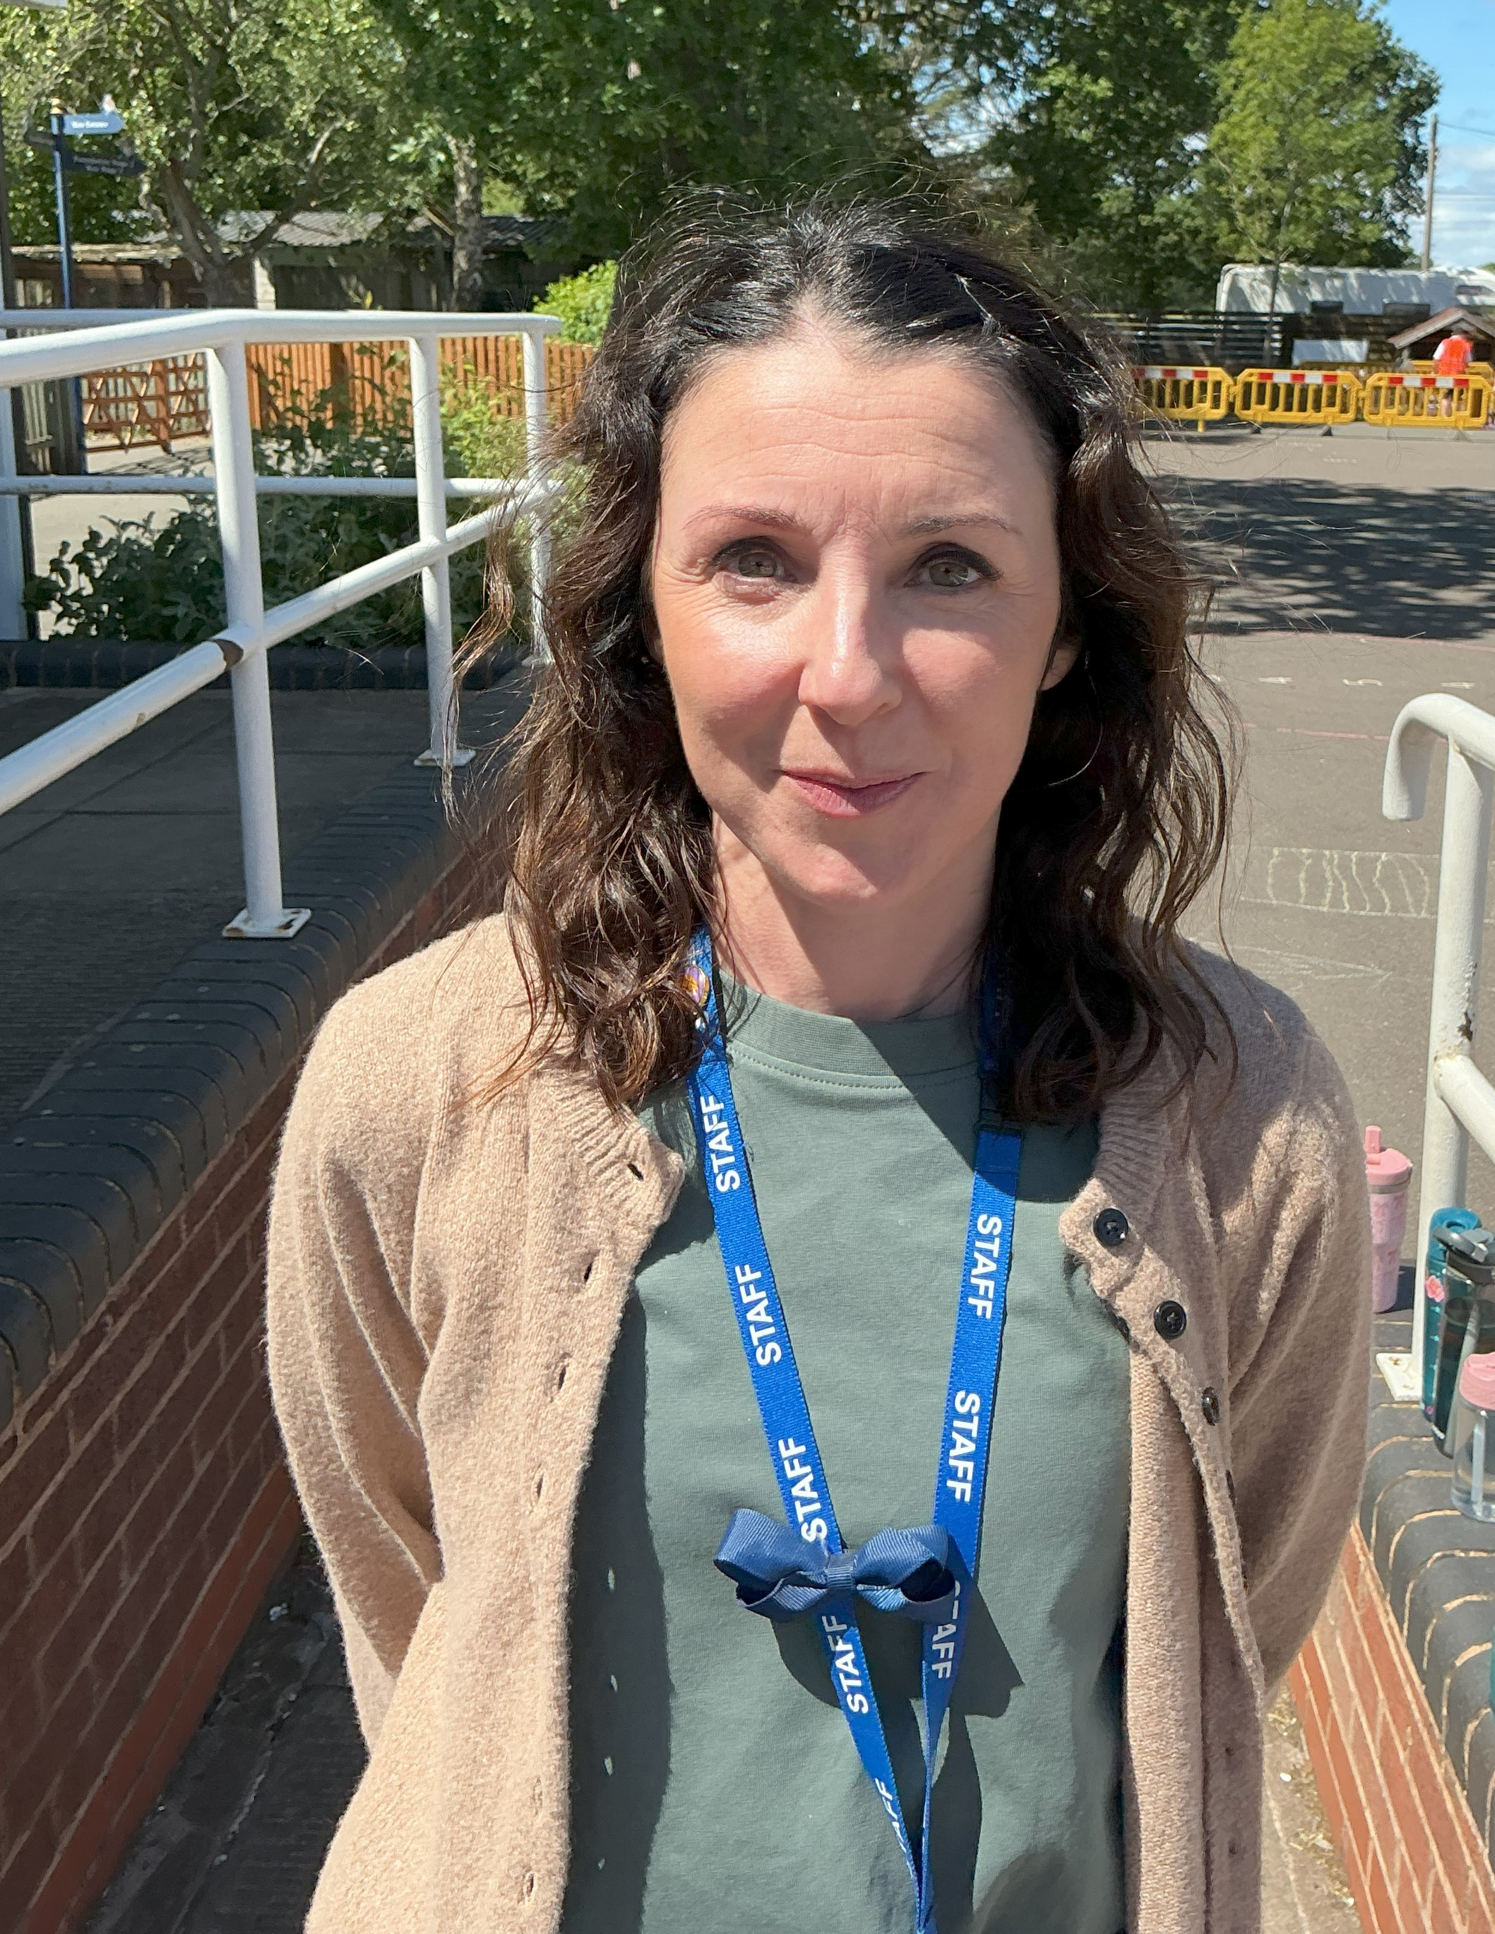 | 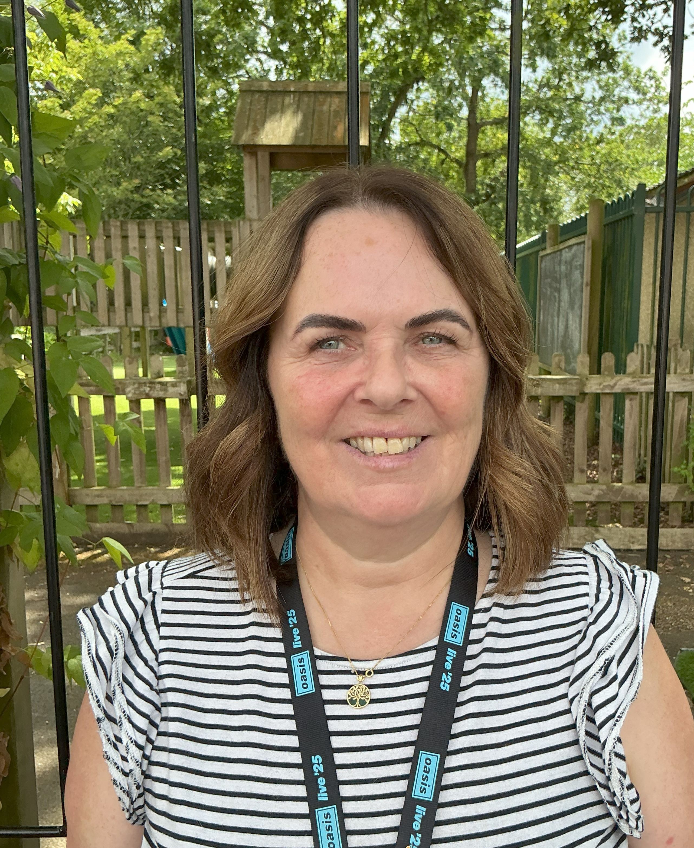 |  | 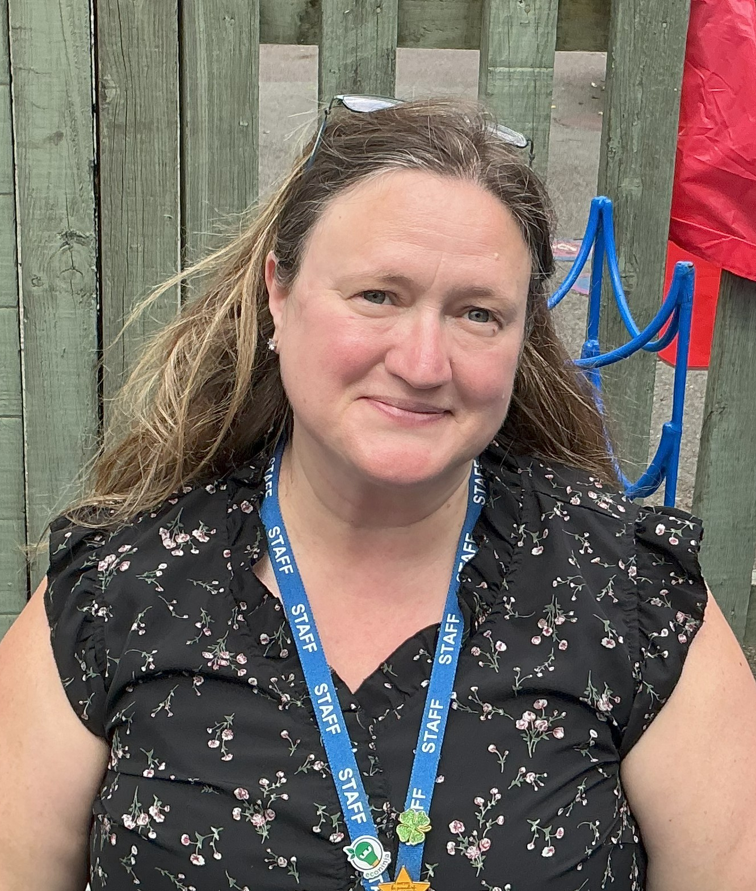 |  | 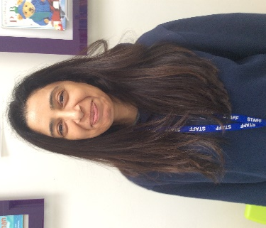
Miss Ellison  Teaching & Learning Assistant | Mrs Caldwell  HLTA |  | Mrs Perry  Teaching & Learning Assistant |  | Mrs Ali  Child & Family Support Worker
Other key members of staff:
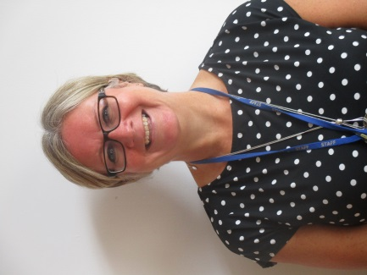 |  | 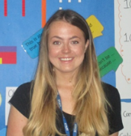 |  | Mrs Ali is a key point of contact for parents, offering drop in advice and support for parents regarding a range of issues that include behaviour and parental support. She also undertakes individual support and group work for children (self-esteem, social skills, friendship, managing feelings, behaviour etc.). Please feel free to book an appointment via the school office if at any point you feel your child or your family need some support.
Mrs Glennon  Head Teacher |  | Miss Rowlands  (SENDCo/Inclusion Lead)
How we support learning in our Foundation Stage
Children are born ready, able and eager to learn. They actively reach out to interact with other people and the world around them. Each child is unique and here at St. Patrick’s we provide them opportunities to interact in positive relationships and enabling environments.

Play underpins the delivery of our early years curriculum. We know that young children learn best through play. Learning that is well-planned, structured and purposeful, both indoors and outdoors is key to providing young children with enjoyable learning experiences where they learn many new skills. Whilst in the Foundation Stage, your child will spend periods of time within the continuous provision, engaged in child-initiated activities they have chosen for themselves. These experiences enable your child to build up important relationships with other children, and allows them to use their own initiative and problem solving skills. It is through these experiences that children learn and develop and our skilled staff guide play to maximise learning opportunities. To complement this, children need to be taught what they don’t already know, which is achieved through focused teaching. This is through mixed groups, whole class sessions, small groups or individual work.
Our environment enables learning to take place in each area of learning and development. Space is provided both indoor and out to allow active or quiet learning with well organised areas and resources that are accessible to the children. When children build their independence it allows adults to spend more time joining in with children’s learning, extending their language and thinking and helping them to make progress.

Planning is linked to the needs of the children, based on their stage of development. Activities are planned for that are purposeful and fun and the children are allowed to extend or adapt those activities to aid their learning. Planning is informed by on-going observations and assessment and is flexible so we can respond to the ideas of the children in order to teach specific knowledge and skills. Learning is reviewed through plenaries which celebrate learning, offer new ideas or identify areas for development.

Children are treated as individuals and we consider their individual needs and interests alongside their individual stages of development. We use this information to plan challenging and enjoyable experiences in each area of learning and development that will ensure children make progress. We recognise that children develop at different rates, have different interests and come from different backgrounds, yet all children are praised and valued for their own achievements. Play underpins all development and learning for young children and we aim for laughter, fun and enjoyment as they are the best contexts for learning.
At St. Patrick’s children are at the heart of what we do and our aim is to support children to be happy and to learn and progress from the moment they walk in the door to the moment they leave.

The Foundation Stage Curriculum
Areas of learning and development
In Nursery and Reception, we follow the statutory Early Years Foundation Stage Curriculum, which encompasses seven areas of learning. Three areas, known as the prime areas, are particularly crucial for igniting children’s curiosity and enthusiasm for learning, and for building their capacity to learn, form relationships and thrive. These prime areas are developed from birth:

Personal, Social and Emotional Development | Communication and Language | Physical Development
Involves helping children to develop a positive sense of themselves, and others; to form positive relationships and develop respect for others, play cooperatively and take turns. They will develop social skills and learn how to manage their feelings. They will understand appropriate behaviour in groups and to have confidence in their own abilities. | Involves giving children opportunities to experience a rich language environment; to develop their confidence and skills in expressing themselves; and to speak and listen in a range of situations. They will learn to follow instructions and ask and answer questions about experiences, stories and events. | Involves providing opportunities for young children to be active and interactive, to develop their coordination, control, and movement. Children must also be helped to understand the importance of physical activity, and to make healthy choices in relation to exercise and diet.

We seek to support children in four specific areas, through which the three prime areas are strengthened and applied. The specific areas are:

Literacy | Mathematics | Understanding the World | Expressive Arts and Design
Involves helping children understand the process of writing, which begins by encouraging children to mark make and then to link sounds and letters and begin to read and write. Children have access to a range of reading material (books, poems and other written materials) to ignite their interest. | Involves providing children with opportunities to develop an understanding of maths through stories, songs, games and imaginative play. They will improve skills in counting, understanding and using number up to 20, calculating simple addition and subtraction problems; and to describe shapes and spaces. | Involves guiding children to make sense of their physical world and their community through opportunities to explore and observe. They have the opportunity to find out about people, places technology and the environment. | Involves enabling children to explore and play with a wide range of media and materials, as well as providing opportunities and encouragement for sharing their thoughts, ideas and feelings through a variety of activities in art, music, movement, dance, role play, and design and technology

All seven areas of Learning and Development are connected to one another and are equally important and depend on each other to support a rounded approach to child development. All the areas are delivered at St. Patrick’s through planned, purposeful play, with a balance of adult-led and child-initiated activities.
As a Church of England school, Religious Education is also an important element of the curriculum. Children will be involved in prayer and collective worship on a daily basis, discussing and reflecting upon our Christian values.

To complement the 7 areas of learning, the Early Years Foundation Stage Curriculum also outlines Characteristics of Effective Learning. The way your child engages with other people and their environment underpins their learning and development across all 7 areas of learning. We support your child to be an effective and motivated learner in a variety of ways:

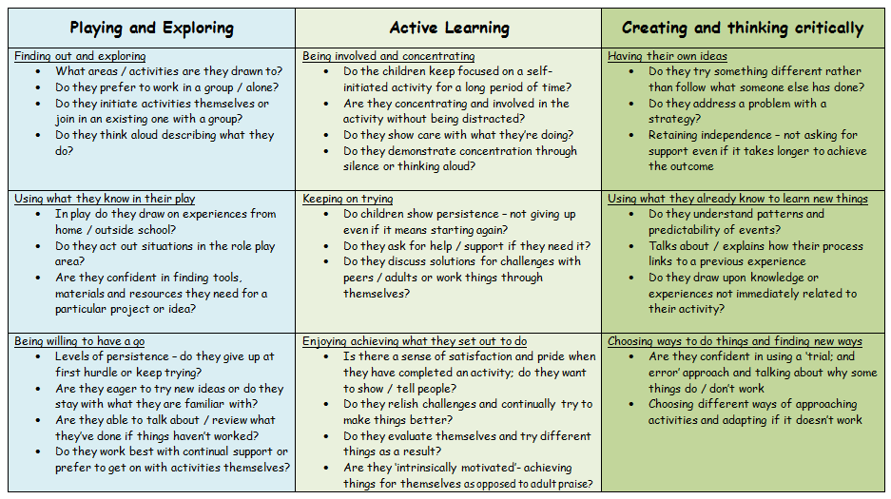

Our thematic approach…
A thematic based approach allows us to deliver all seven areas of learning in a coherent way which is meaningful to the children. However, our curriculum is bespoke to our children and what is taught does change year on year, depending upon the children’s interests and unique needs. Any one experience for the children may provide the opportunity to develop skills, knowledge and concepts across several areas of learning. Our activities are based on the following cross-curricula themes:
 | Autumn Term | Spring Term | Summer Term
Nursery | Me and My Family  Traditional Tales | People who help us  Amazing Animals | Places to Visit  Fantasy
Reception | Being Me  Celebrations and Good Times | Once upon a time | Are we there yet?  Africa

Our overarching curriculum plans for both Nursery and Reception classes can be found on our website. They will support you in understanding what we are covering on a termly basis but please note that our plans are very fluid and staff will choose to take learning in different directions to take account of the children’s own ideas, their interests and where best to progress learning.

Assessment in the Foundation Stage
Practitioners working alongside your child will continually make observations and assess your child’s stage of development which will support the planning of future activities. Many observations will not be recorded, some will be paper based and occasionally they will be recorded electronically on iPads. These observations feed into the school’s secure online assessment system.

How can you support us and your child?
We work alongside parents, informing and listening to their opinions of children’s development. By sharing information about their children’s interests, strengths and needs, parents help the adults who work with them to plan experiences and activities that are fun. At St. Patrick’s we develop this relationship with parents in a variety of ways.
We value the involvement of parents in:
- Curriculum workshops
- Parent consultation meetings
- Within the classroom, as parent helpers.
- Feeding into your child’s Foundation Stage Profile.

Before your child starts Nursery or Reception you will be invited to a New Parent’s Meeting. Children are also invited to spend some time in their new classes in the summer term.

Parent’s Consultation Evenings are held during the year, one towards the end of October and the other towards the end of the spring term. Interim reports are provided at these consultation evenings and a full report is sent out to parents annually in the summer term. There is also a chance to meet with your child’s class teacher at the end of the summer term. Staff are always happy to speak with you after school if you have any queries or concerns.

Helping out in school – We very much welcome parents to help support activities within school and at forest school. We appreciate any support you can give. Please let the school office know if you would like to help out as we will need to order a current DBS check. From time to time you may think you can support us with one of our topics, either by providing us with artefacts, photos or other objects relevant to the topic, or by coming and giving a presentation to the children on a specific theme. Please let us know if you think you can help.
Play dough – We cannot get enough play-dough. It is really easy to make. There is a play dough recipe at the end of this booklet. If you would like to have a go at making some play dough to send in for us we would be more than grateful

How can you support your child at home?
To ensure a happy start, talk to him or her about what they will be doing at school. Talk to other children who have started school. Find some stories about children starting school to allay any fears they may have.
Personal Care and Hygiene - Before coming to school, children should be confident in going to the toilet by themselves. Please help and encourage your child to roll up their sleeves and wash their own hands. Let your child practise getting dressed independently (including putting on coats and doing up zips), even if it does take a long time! A collection of dressing up clothes can help develop these skills in an enjoyable way. Dressing Dolls and teddies provides useful practice in fastening buttons and zips.
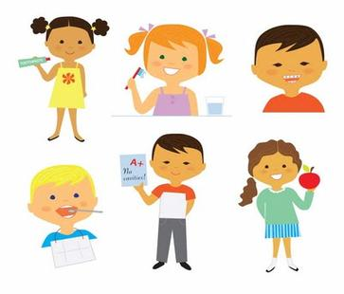

Sharing and Taking Turns - Sharing and turn taking are often difficult concepts for children to learn. Give lots of praise when your child shares with others to encourage this behaviour. Play games which involve taking turns.
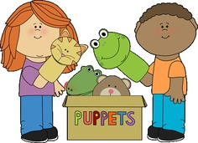
Tidying up - Please encourage your child to to tidy away their own toys at home. At school children are expected to tidy up after themselves, not leave things for an adult or another child to tidy away.


Understanding Rules - Talk about and explain why we need rules. Children need to understand why it is dangerous to run indoors, or to throw sand or bricks. Recognising that you have similar rules at home will help your child to integrate more quickly into our school, and make it a safe and happy place in which to learn and play.
Writing - Children need lots of opportunities to make marks on paper. These marks have real meaning for children, and are the beginnings of writing. Children learn about writing by noticing print and watching others. Try and give them opportunities to ‘write’ for themselves – lists, signs, cards and invitations. Provide your child with plenty of materials and tools to mark make with and above all else, praise and encourage them for having a go. There are handwriting and phonics resources at the end of this booklet.
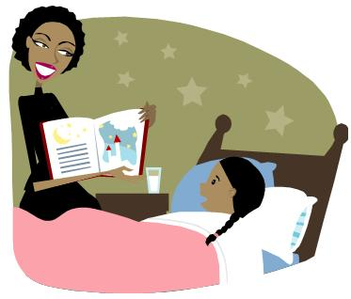
Reading - Children who are read to and enjoy books from an early age are most likely to be successful readers in the future. Try and share a book with your child as often as possible. If you speak different languages it is important that your child can share this with you when looking at books. Reading together can also involve telling stories, you reading to your child, reading print in the world around you, eg labels on tins and visits to the library. Try and include a variety of texts as even comics can spark off an interest in reading!
- Try and find a quiet and comfortable place and sit so that you can both see the book. When you are listening to your child, start by looking at the cover of the book and talk about the book first. Encourage your child to hold the book and turn the pages.
- As your child reads, encourage your child to find clues in the pictures to help them with new words, encourage them to try to guess what a new word might be by looking at the text, help them with any sounds they know and don’t be afraid to read the words for them if that helps with the flow.
- Ask them questions and talk about the book to help them understand what they have read. Can they tell you anything about the characters in the book? Or what they think might happen next?


Maths - There are lots of different ways you can help your child at home with mathematics.

- Use as many opportunities as you can to count with your child – stairs and steps, buttons, fruit etc. Look for numbers around you and recite counting rhymes.
- Look for shapes around your home, use the correct names and encourage your child to talk about features of different shapes. [E.g. number of corners, sides etc.]
- Look for patterns around you such as laying the table, in books and with their toys.
- Playing board games and card games are important ways to help children understand about addition and subtraction.
- Involve your child in shopping trips by counting money and talking about prices.

Understanding of the world around them - Young children are naturally very curious and ask many questions. Wanting to know how does it work? What happens if…? Why does..? etc is typical of children of this age, and there are many activities that encourage early scientific skills of observation, prediction and experimentation. Talk to them about what is happening around them, explore and try to find out answers. For example:
- Plant cress seeds and watch them grow each day. Sprout carrot tops and potatoes on saucers.
- Make collections of pebbles, shells and leaves. Sort these objects using describing words such as smooth, hard, heavy and rough.
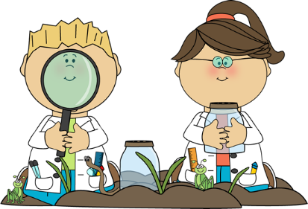
- Encourage your children to talk about the weather and how different weather conditions affect our lives.
- Work with water and let your child find out about bubbles or floating and sinking in a washing up bowl or in the bath.
- Look at photographs of family and friends. Talk about how we change as we grow.
- Notice the different jobs that adults do as you go shopping.

Useful Websites for Parents/Carers:
https://www.solihull.gov.uk/Children-and-family-support/localoffer/early-years-support
https://www.bbc.co.uk/tiny-happy-people
https://www.solgrid.org.uk/fivetothrive/parenting-advice/
https://eric.org.uk/
https://healthforunder5s.co.uk/sections/toddler/your-video-guide-to-toilet-training/
https://healthforunder5s.co.uk/sections/toddler/why-routines-matter/

General Information
School times – Drop off and collection

 | Drop off | Collection
Nursery | Core Nursery hours are 8.45am – 11.45am  We welcome the children into Nursery from 8.35am. A member of staff will be on the gate to welcome them. They will enter the classroom through the outdoor area. | Nursery children will be released at 11.45am. Please be prompt for pick up.  For safeguarding reasons, we release children from the main entrance to school. We ask that you wait on the other side of the gate as it enables us to hand over children to their parents efficiently and safely. Please let us know if someone different from usual is collecting your child by informing staff in the morning or by phoning the school office. For safety reasons, if it is someone that we do not know collecting your child, we ask that you provide the person picking up your child with a password and inform the member of staff on duty in the morning.
Reception | Reception hours are 8.45am – 3.15pm  Reception parents can drop off children at the gate at 8.35am. Urgent messages can be passed to the member of staff on the gate. Staff will collect the children from the playground at 8.35am and take the children to their classrooms. Morning registers will be taken at 8.50am and any latecomers will need to report to the office in the main school. | Reception children will be released at 3.15pm. Please be prompt for pick up.  Reception children are released from their outdoor classroom. We ask reception parents to remain in the main playground on the other side of the gate as it enables us to hand over children to parents efficiently and safely. Please let us know if someone different from usual is collecting your child by contacting the school office. For safety reasons, if it is someone that we do not know collecting your child, we ask that you provide the person picking up your child with a password and inform the member of staff on duty in the morning.

Uniform
Please ensure all items of clothing and footwear are clearly labelled to avoid confusion and loss of uniform. Please do not allow your child to wear jewellery to school (if any artefact has to be worn for religious reasons do please discuss this with us). The children have regular access to the outdoor area and we would therefore ask that children are suitably dressed for outdoor play in all weathers – your child will need an outdoor coat with a hood with them every day. Timings within the classroom on a daily basis are flexible to allow for the children’s interests and sustained involvement in activities. Further details on uniform can be found on the school uniform policy.

Snacks / Drinks
Milk and fruit are provided free for all children up until the age of five. We would like children to bring in a clearly named water bottle to drink from. This should contain PLAIN WATER only.

P.E. Kits
The Nursery and Reception children WILL need a P.E. kit immediately for use from September. The day(s) children have a P.E lesson will be communicated to you and on these days, children will attend school in their P.E kit. They will require navy shorts, navy tracksuit bottoms and a school PE top (see school uniform list).

Spare clothes
All children will need a set of spare clothes including pants, socks, school top, trousers/skirt/dress to be kept in school in case of any play or toileting accidents. Please send these in a named pump bag which will be kept on your child’s peg in school.

Home Learning
In Nursery, homework will be provided later in the year, when appropriate and usually takes the form of short, fun activities to do at home.
Reception pupils will be provided with school reading books every week. They shall be changed once a week. Your child will be given a home reading diary and we ask that you record what and when you have read with your child. You are more than welcome to leave comments about the books you have read or about how your child read. Children will also be given weekly phonics homework and a range of other activities.

Library
Library books will be changed once a week. You will be told what day books will be changed on at the start of the Autumn term.

Absences
If your child is absent from school, please notify the office detailing the likely date of return and reason for absence.

Personal belongings
Please do not let your child bring toys/valuables from home unless asked to by staff as part of the children’s learning.

Social Media
We now live in a world where social media is very much a part of our lives whether we use it or not. It is now commonplace for parents in year groups to set up class communication groups. Where this happens we ask that the groups are inclusive of all and that they remain positive and supportive forums. Should a parent have a concern, we ask that they contact the class teacher so it can be resolved in a professional manner.

Birthday celebrations
We love to celebrate birthdays in school. If you want to celebrate your child’s birthday by bringing treats for the class please do not bring lollypops, hard sweets or sweets with nuts. Please also avoid Haribo as it contains gelatine which is unsuitable for vegetarians. The children take the treats home to eat.

School Fund
Parents are asked to make a voluntary contribution to our School Fund. These voluntary contributions make a huge difference supporting trips, visits and fun activities for Nursery and Reception. All funds collected directly benefit your child. For further details, please see the school office.


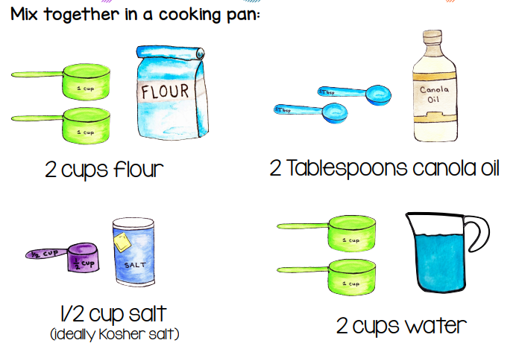
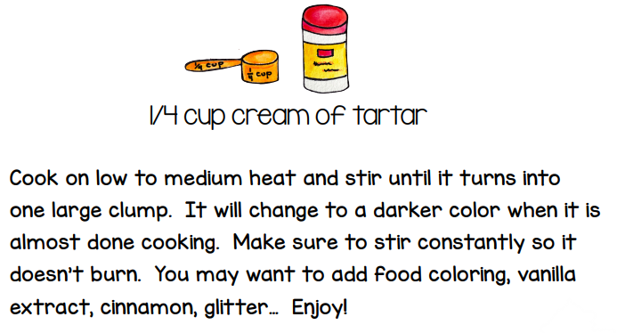
Alternatively, mix the ingredients and place in the microwave for 5 minutes.
Canola oil is vegetable oil.

